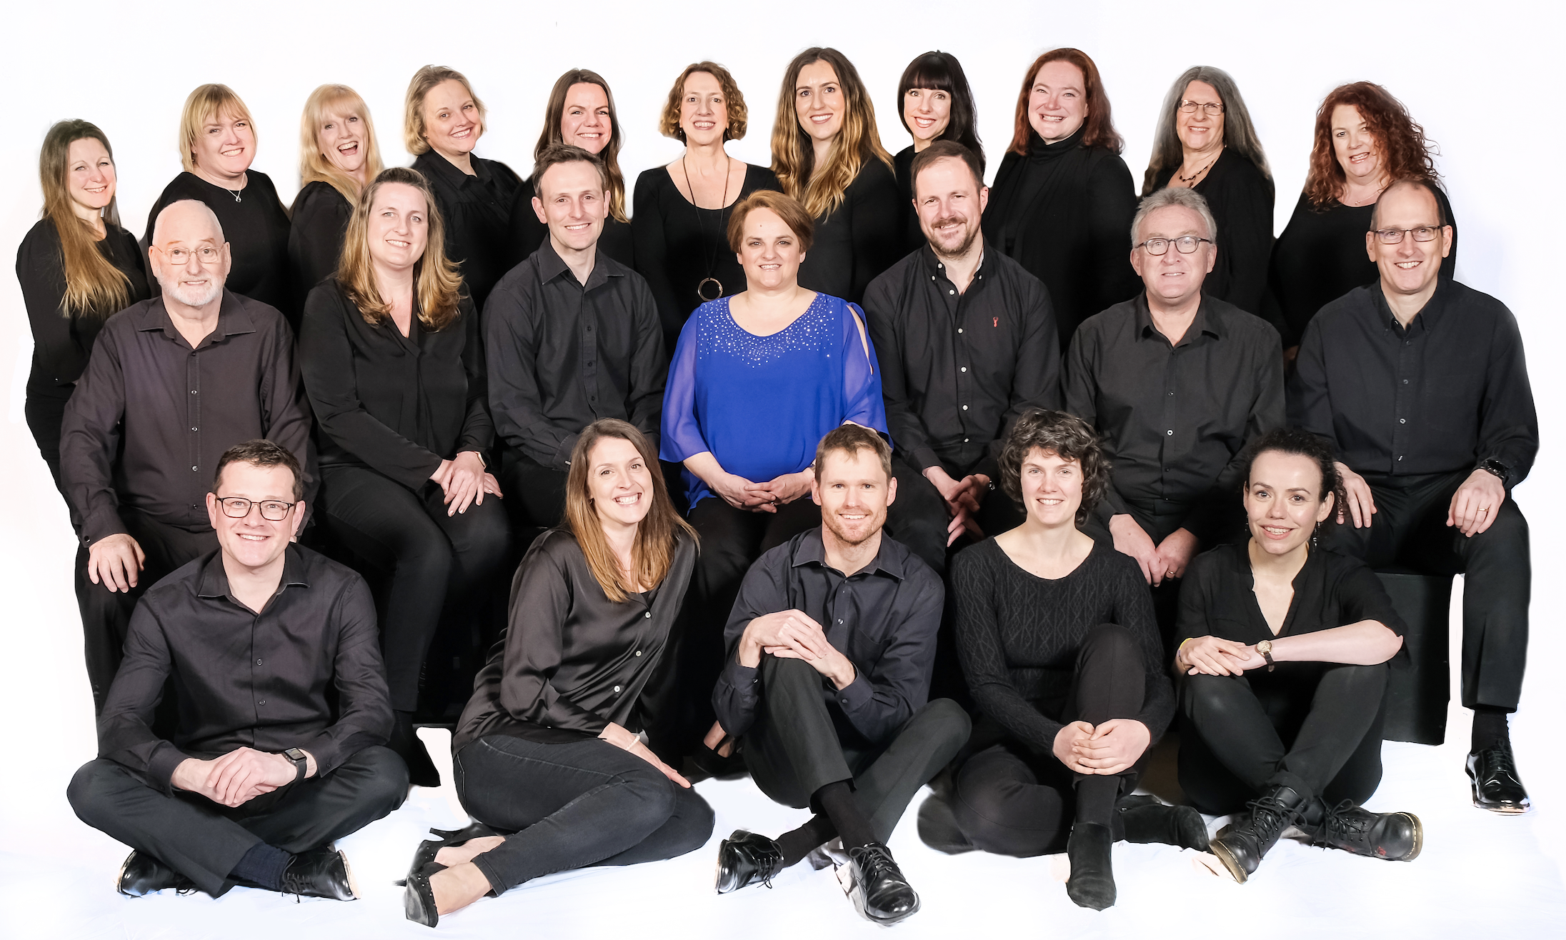

Tamesis Chamber Choir

SOPRANOS: Vicky Elmore, Clare Garner, Louise Hill, Suzanne Hinch, Tanya Houghton, Julie Kench, Jo Loxton, Anne Owen, Miranda Phillips and Tamsyn Wilson
ALTOS: Emily Cooper, Charlie Hobson, Alison James and Emily Reed
TENORS: Tim Beavan, Nick Brown, Alistair Cawdron, Laurence Hicks and Jude Watts
BASSES: James Allen, Andy Button, John Cobb, Oliver Hames, Harry Jackson, Patrick Moore and David Webb

Please fill in our short survey about how you came to be here today



Tamesis Chamber Choir was founded in 2003 and has carved a niche in the Berkshire area: members are auditioned each year to maintain the highest standards, and we sing a variety of styles of high-quality music. It’s also important to us that the choir has a lively social aspect!
Tamesis is the Latin name for the River Thames, reflecting our links to Reading and the surrounding area. We perform regularly to raise funds for local and national charities and have featured several times on local radio and on BBC Radio 3. Tamesis has been styled ‘one of Berkshire’s best ensembles’ in local press. Our three CDs, Spirituals, Remembrance and Christmas, will be on sale this afternoon.

A big thank you to the team at Our Lady and
St Anne’s for their support and the
opportunity to perform in this lovely venue

Thanks also to Alison James and John Cobb
for accompanying this afternoon, and to Charlie Hobson for reading her beautiful Advent poem
Advent into Christmas

It's our great pleasure to welcome you this afternoon to enjoy our warm and inviting musical journey into Christmas. The programme traverses the changing moods of the season, from the quiet, reflective anticipation of Advent to the bright joy and celebration of Christmas Day. We've chosen a blend of traditional and contemporary pieces that convey both the ancient significance and enduring modern joy of Christmas time.
We hope this beautiful choral music will bring you moments of peaceful reflection and send you on your way with spirits uplifted for the festivities ahead.

Reflection and anticipation
To explore the meditative atmosphere of Advent, we reach back to the 16th century with Tallis's serene O nata lux. This beautiful motet's interwoven vocal lines create a calm, luminous texture that invites quiet contemplation. Rachmaninov’s Bogoroditse Devo (Hail Mary) is a staple of the Russian Orthodox tradition. The rich, yearning harmonies of the choir convey a deep sense of devotion. Britten’s Hymn to the Virgin continues the ethereal mood, alternating choir and semi-chorus singing the Old English text. Contemporary composer Shephard’s lyrical setting of the yearning Advent poem Never weather-beaten sail sumptuously amplifies its meditative theme.

Classic and contemporary carols
Our programme embraces the classic tradition of the carol while also showcasing how modern composers interpret this form. As we look into the heart of Christmas, we embrace the joy of the season with Mendelssohn’s uplifting Frohlocket. Cashmore’s arrangement of Praetorius’s Baroque German carol Es ist ein Ros is a simple and timeless celebration of Mary's bliss. In his recent setting of the Coventry Carol, Gjeilo uses contemporary harmony to give a familiar melody a gorgeous new glow. And no carol concert would be complete without a contribution from Rutter, whose talent for accessible and emotionally rich festive composition manifests with rare subtlety in What sweeter music.

Celebration and community
With difficulty, we selected just four of The Manchester Carols, an inspired 2007 collaboration between composer Johnson Manning and the then-Poet Laureate, Carol Ann Duffy. This collection offers a fresh and engaging re-telling of the Christmas story, focusing on human experience and its relevance to modern society. A robust piece of English carol tradition comes in Vaughan Williams's Fantasia on Christmas Carols, a fusion of well-loved carols bursting with warmth and good, old-fashioned Christmas spirit. Rathbone's lively Carol Medley is another wonderful Christmas gift that wraps in yet more festive favourites.
We’ll bid you farewell in rich harmony with the classic Have yourself a merry little Christmas. This features on our professionally recorded Christmas CD, which you can buy this afternoon at half-price if by any chance you don't already own one!


Louise Rapple Moore studied conducting at the Conservatoire de Pau in southern France whilst at university and began her conducting career by directing the Reading University Singers. She spent several years in Church music as an organist and choir director and founded Tamesis in 2003. She also directs Tamesis Cathedral Singers, an occasional choir that sings Cathedral Evensongs twice a year.
Louise is founder and director of Shiplake Community Choir and Hagbourne Community Choir, both choirs for singers of all ages and abilities singing a mainly popular repertoire. In October 2013 she was delighted to be recognised for both her work as a Choral Director and her charitable fund-raising efforts by being named Creative Woman of the Year in Sue Ryder’s annual ‘Women of Achievement’ awards at the Madejski Stadium in Reading. In 2017 she gained her LRSM in Choral Conducting via the Advanced Conducting Course with the Association of British Choral Directors.

Upcoming events

Saturday 21st March 2026, 7pm
The Inaugural Tamesis
Pudding Concert!

You read that correctly – we will holding
the crème de la crème brûlée of concerts with a selection of desserts served in the interval. This will be a flan-tastic evening,
so please save the date (pudding)! As Chat GPT offered when I asked it for dessert-related concert puns: “Come for the
beats, stay for the sweets”!

Saturday 20th June 2026, 7:30pm
Summer Concert
Douai Abbey, Woolhampton

We are very much looking forward to returning to the gorgeous Douai Abbey for our summer concert. Always a favourite venue with choir and audience alike,
please do put the date in your diaries.

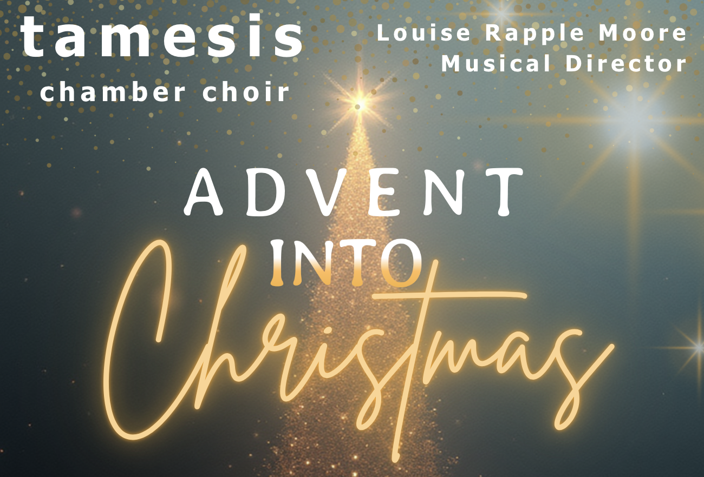

Our Lady and St Anne’s, Caversham
Sunday 7th December 2025, 4pm

Programme

O nata lux Thomas Tallis

Es ist ein Ros’ entsprungen Trad. German
arr. Praetorius and Donald Cashmore

Never weather-beaten sail Richard Shephard

Bogoroditse Devo Sergei Rachmaninov

Fantasia on Christmas Carols
Ralph Vaughan Williams
Baritone: David Webb

Coventry Carol arr. Ola Gjeilo
Soprano: Jo Loxton

A hymn to the Virgin Benjamin Britten
Semichorus: Vicky Elmore, Emily Reed,
Alistair Cawdron and Oliver Hames

Frohlocket, ihr Völker auf Erden
Felix Mendelssohn

What sweeter music John Rutter

Four songs from The Manchester Carols
Sasha Johnson Manning
Soprano: Julie Kench
- Annunciation
- Christmas flowers
- Call it Nazareth
- Mirabile dictu

Carol Medley arr. Jonathan Rathbone
Soprano: Tamsyn Wilson, Alto: Charlie Hobson, Tenor: Tim Beavan, Bass: Patrick Moore

Have yourself a merry little Christmas
Martin/Blane, arr. Peter Gritton

